41-067-001 Rockland VerticalMicrostructureProfiler_VMP Manual

Contents
Contents 1
Book and check the VMP 2
Prepare config file 2
Set up the VMP 2
Bench test 4
Operate the winch 5
Set up the VMP in the field 5
Measuring with the VMP in the field 7
Back in the lab - Treatment and administrative tasks 8
Changes to previous versions 9

Book and check the VMP
- Book the VMP by contacting Michael Plüss, michael.pluess@eawag.ch
- Fill in the first three columns in the logbook and read the manual
  - Q:\Abteilungsprojekte\Surf\surf-KB\Aphys Messgeräte\Rockland\vmp
- Check if the VMP has any damages

Prepare config file
- Generate a copy of the latest VMP *.cfg file.
- Change name (either generic bench test file name or upcoming fieldwork [FW])
  - Save it in the folder(directory) where the data to be collected will be stored (either BenchTest or FW-specific folder), labeling it with the modification date in yyyy_mm_dd format. For example: setup_EAWAG_2018_09_13.cfg
- Modify accordingly:
  - Shear microstructure (sh1 and sh2 channels) sensitives (sens). These are probe-specific and have to match the probes used in the field. The sensitivity of each sensor is provided by Rockland in the Shear Probe Calibration Report sheets (...\VMP\Kalibrationen\)
  - SeaBird CTD calibration parameters for temperature (T) and conductivity (C). This step is essential after CTD calibration by the manufacturer; otherwise, keep the values as of the latest CTD calibration.

Set up the VMP
- Disconnect the cable from the pump
  - As soon as the VMP is powered, the CTD pump starts running. The pump will overheat when operated in air.
- Connect all CTD pipes
  - CTD-pump pipe
  - Check state of T-C pipe connection (L-shaped rigid pipe)
- Fluorometer
  - Make sure that led lights are scanning a free volume (away from the protecting frame)
  - Make sure that the fluorometer is opposite to the CTD.
- Connect all cables (except the one for the pump)
  - Orange winch cable to VMP: put the cable from the top of the VMP, follow the curved path, go through the hole and come back to the plug through the bottom opening (see pictures below). Fix the cable with the metallic plate and the black cap on top (screws requiring two 8 wrenches). Add protective tape on the wire.

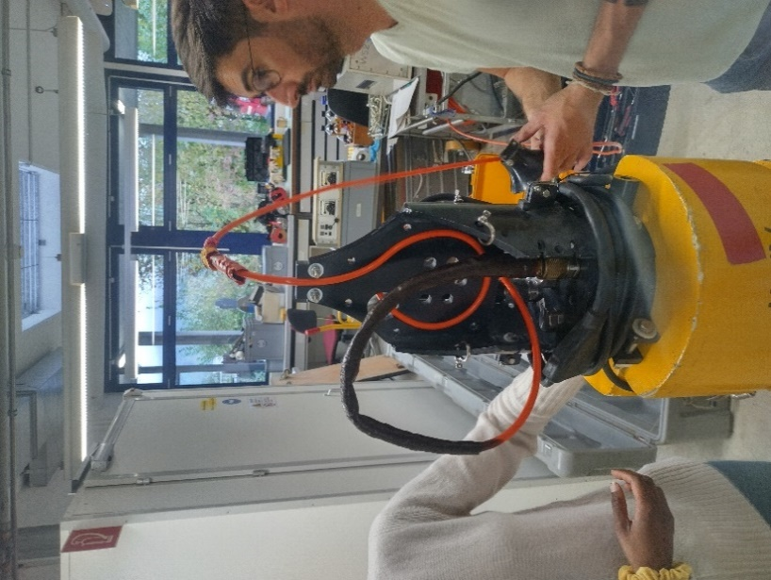
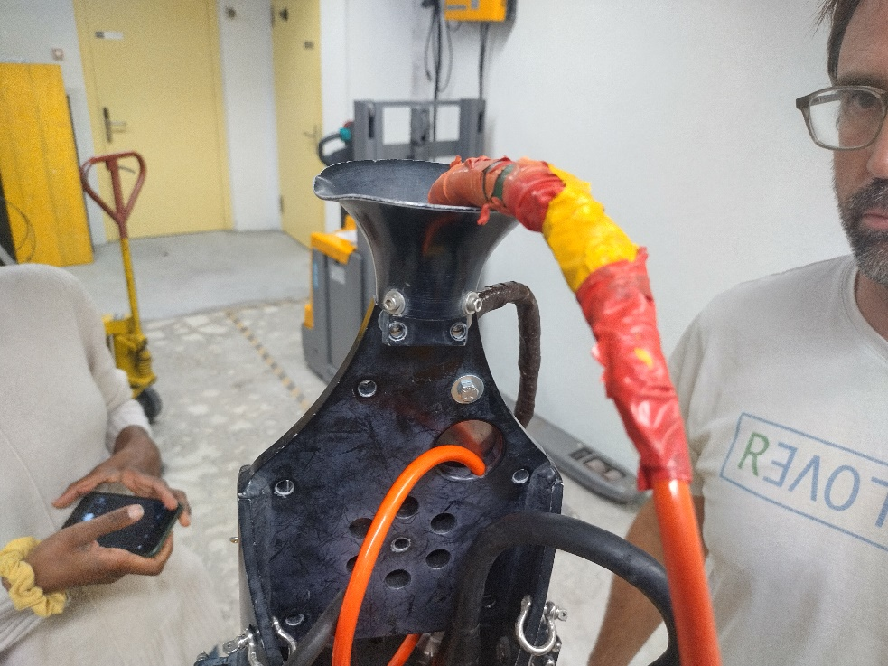

  - Orange cable from the yellow box to the winch.
  - Power cable to socket: fluorometer should show a blue light.
  - USB cable to computer: all the LED should be on (red and green) on the black unit in the yellow box.
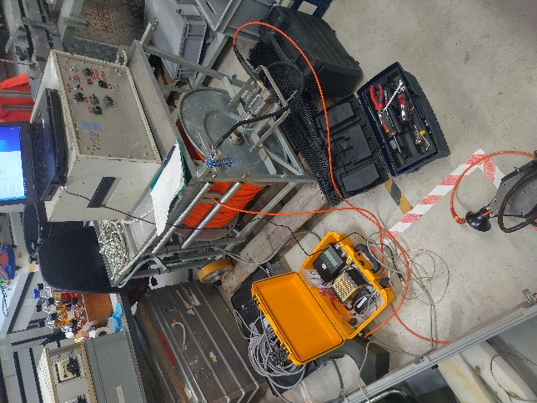
1
2
3
4

3
2
1
- Start ODASRT software
  - Choose the setup file (*.cfg)
  - Change the file prior to this step if other probes have been installed or sensitivity has changed
- ODASRT Calibrate tab
  - Click “Calibrate” button
  - Channels should all show “true” and switch from blank to green.
If they show “false” (red), it is likely that there is a connection issue. Check that all cables are connected, in particular the computer cable in the VMP yellow box.
- ODASRT Real Time tab
  - Click “Connect”
  - Note down pressure (P1) (used later for manual correction of pressure)
  - “Fall rate” should show 0 if the VMP is not moving
  - Click “Disconnect”
- Matlab
  - Set up the location of the VMP setup file as the workspace directory.
  - Type >>cd 'where setup file is located' (or browse to the directory using the Matlab GUI)
  - Type >> addpath(‘/path/to/ODAS/folder’) to add ODAS library to the workspace directory
- ODASRT Real Time tab
  - Click “Connect”
  - Click “Start Recording” and wait for 5s (new .P file and a log file are being generated)
- Matlab
  - Type >>plot_VMP – a plot window should pop-up showing raw measured data.
- Check that there is a plot with Ax, Ay, T1, C1, S1, S2, P, dP, JAC-C, JAC-T (not all the channels).
- ODASRT Real Time tab
  - Click “Stop Recording”
  - Click “Disconnect”

Bench test
- ODASRT Real Time tab
  - Calibrate all channels (All channels should show True in green; debug otherwise)
  - Click “Connect”, click “Start recording”. Generate a file of at least 60 s.
  - Click on “Stop recording”.
- Matlab
  - Type >>quick_bench(‘VMP00X.p’,’28’). Change ‘X’ accordingly to match the VMP file. ‘28’ corresponds to our VMP’s serial number.
  - Two plots will emerge: (i) Time series of raw data and (ii) Spectral response.
- Follow and fill the form: Rockland_Bench_Test_ChecklistV3.pdf (located in the BenchTest folder)
- Note that our VMP (SN 028)
  - Is an old instrument with an old “real” (3-axis) accelerometer, which responds differently than current vibrations sensors (outputting values centered around 0 for which the current bench test form was designed for). According to exchange with Rockland on May 2022, accelerometer values fluctuating round Ax~6000, Ay~4000 are expected.
  - It has two (2) conductivity sensors (C1, C2)
- Compare to last bench tests. If results are weird or a bench test has not been performed for a long period, report to Rockland (send *.p file and filled bench test form)

Operate the winch
- Plug in all cables
  - Transformer power supply to generator
  - Control unit power supply to transformer
  - Winch to control unit
  - Potentiometer to control unit
  - VMP box to winch slip ring
  - VMP to winch
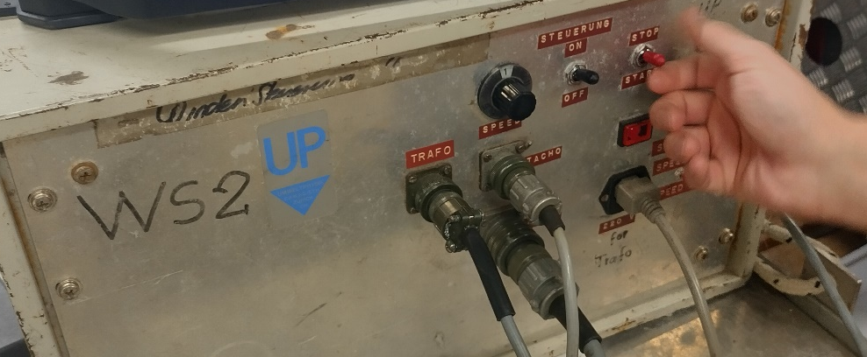
- Make sure that the brake screw is untight and that the “rolling” screw is tight (it should be hard to move the winch manually).

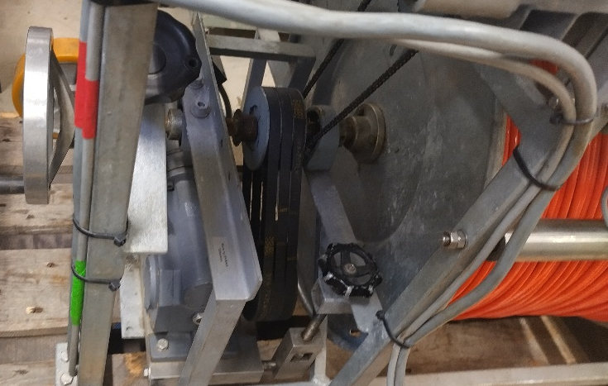
Brake screw
Rolling screw
- Turn on the control unit with the ON/OFF switch (make sure that the right switch is on STOP)
- Use the UP/DOWN switch to control the direction of the movement
- Use the START/STOP switch to turn the winch on and off
- Use the INTERNAL/EXTERNAL switch to choose the used Potentiometer
- Use the Potentiometer to adjust the speed
- Find an appropriate speed to maintain a few meters slack

Set up the VMP in the field
- Prepare as much as possible on the shore. You need to be at least two people to operate the VMP in calm conditions; three is more convenient and highly recommended for inexperienced users. The absolute wind speed limit for operations is 20km/h (10 km/h if the team is composed by less or equal to one experienced user)
- Follow the “Set up the VMP chapter”. Steps to follow on the shore:
  - Unplug the VMP pump.
  - Bring the end of the winch cable to the shore and plug it to the VMP. It is easier to do it if the VMP is standing.
  - Connect all the cables between the winch, controller unit and VMP box.
  - Put the VMP horizontally on the ground (using the foam pieces).
  - Plug the VMP: check that the fluorometer is on. Connect the computer.
  - Perform a bench test.
  - Unplug the VMP.
- Connect the sensors to the VMP and be very careful not to touch the tips of the microstructure sensors
Important: Check § 3.7 Installing Microstructure Probes in the VMP-500 User Manual provided by Rockland Scientific (...VMP\Manual\Manual_VMP500RT_PN-010-047-20_2020-10-02.pdf)
Order of installation: microconductivity probes, shear probes (one oriented along x axis that goes through pressure sensor, the other one oriented along the perpendicular y axis) and FP07.
- ODASRT Real Time tab
  - Click “Connect”
  - Check if the sensors output reasonable values
  - Click “Disconnect”
- Connect the brushes to the VMP such that they can move downward from the horizontal position.
- Disconnect the power cable.
- Connect the pump.
- Move the VMP to the boat and prepare it for transport. The best approach is to lay it down at the front of the boat with the sensors facing the water and the brushes not touching the ground, or one brush being horizontal on the ground. Make sure that the VMP is stable during transport.
- Once at the profiling location, prepare some spare cable.
- Attach a rope to the top of the VMP and use a winch to help carrying the VMP vertically. Put the VMP in the water so that it is submerged. Remove the rope.
- Reconnect the power cable (Remember – The CTD pump should not be operated outside the water!)
- ODASRT Real Time tab
  - Click “Connect”
  - Read the pressure (P2): P2 - P1 should be comparable to the length of the instrument (check this just to double check that the instrument is working correctly!). The pressure offset is P1 (for post processing)
  - Click “Start recording” and wait 5s
- Matlab
  - add path to ODAS Matlab files (i.e., type >>addpath(‘/path/to/ODAS/folder’)) or use the GUI.
  - Type >>plot_VMP – a plot window should pop-up showing raw measured data.
- First profile
  - The first cast mainly checks the sinking speed (ballasting) and your cable management so do not profile close to the bottom. The sensors are very sensitive and easily break. Be careful.
  - Let the VMP sink by giving some slack cable continuously. Besides installing the sensors, this is the trickiest part. If the instrument is not "free-falling", the cable tension will add vibrations rendering the profile useless for small-scale analyses. The best approach is to give some slack by hand at the beginning and turn on the winch just before all the slack has been used. For a sinking speed around 0.25 m/s, the winch speed units should be between 2 and 3.
  - Check the profile on ODASRT Real Time tab and on Matlab using plot_VMP. Check that the speed is constant and that there is no vibration (Ax, Ay).
- Ballasting
The sinking speed of the VMP will depend on its weight in water and ambient water density. Installation/removal of additional weights modifies the sinking. Some sinking speed guidelines for turbulence measurements:
- 0.3-0.4 m/s for shear turbulence using both shear and fast terminator probes (This mode was tested for L. Geneva only).
- > 0.6 m/s for shear turbulence using shear turbulence probes only (energetic environments, e.g., large lakes under windy conditions). The reference falling speed for shear microstructure in the ocean is 1 m/s.
- ~ 0.1 m/s for convective turbulence using fast temperature probes only (e.g., Lake Cadagno, Lake Zug pelagic hypolimnion).
Additionally, check that the weight distribution is symmetric, preventing the instrument from tilting/rolling.
- Profiling
- ODASRT Real Time tab
  - Check the sinking speed and check if it fulfills your needs throughout the water column.
  - Check the plot obtained using plot_VMP.
Raw accelerometer data should be stable, showing a linear trend without vibrations/spikes. If this condition is not fulfilled, check ballasting, cable management (See also point 13.2 above) and or pulley. The pulley system is meant for pulling out the instrument only. Install the VMP cable on the pulley only after finishing the profile.
  - At a specified depth (away from the bottom), visible as pressure, click “Stop recording”
- Immediately after stopping the profile, install the cable on the pulley and start pulling up the VMP using the winch.
- ODASRT Real Time tab
ATTENTION. In the beginning the VMP will continue sinking after start pulling the cable. Continuously check the depth on ODAS Realtime to avoid crushing the bottom when performing deep profiles. The best preventive measure is caution and having a reasonable idea of how much cable was given (this can change as a function of wind conditions). Marking the VMP cable in advance is highly recommended.
- At the surface you can adjust your cast management, define at which depth you will start to pull the VMP back
- In case you need to take the VMP out of the water, disconnect the power to prevent damage to the pump

Measuring with the VMP in the field
- After following the chapter “Set up the VMP in the field” continue as following
- ODASRT Real Time tab
  - Click “Start Recording” and wait for 5s
- Matlab
  - Type >>plot_VMP
- Let the VMP sink, manage the cable
- Matlab
  - Watch the plot to verify there are no mechanical vibrations
- ODASRT Real Time tab
  - Click “Stop recording” at specified pressure
- Pull up the VMP to the start depth
- Repeat steps 2 to 7 for multiple profiles
- ODASRT Real Time tab
  - Click “Disconnect”
- Disconnect the power cable
- Take out the VMP
- Rinse sensors with distilled water
- Go to the shore
- Dry the sensors preferably with dry, compressed air and remove them gently
- Disconnect the brushes and cables
- Put back the VMP in its case as shown in the picture below

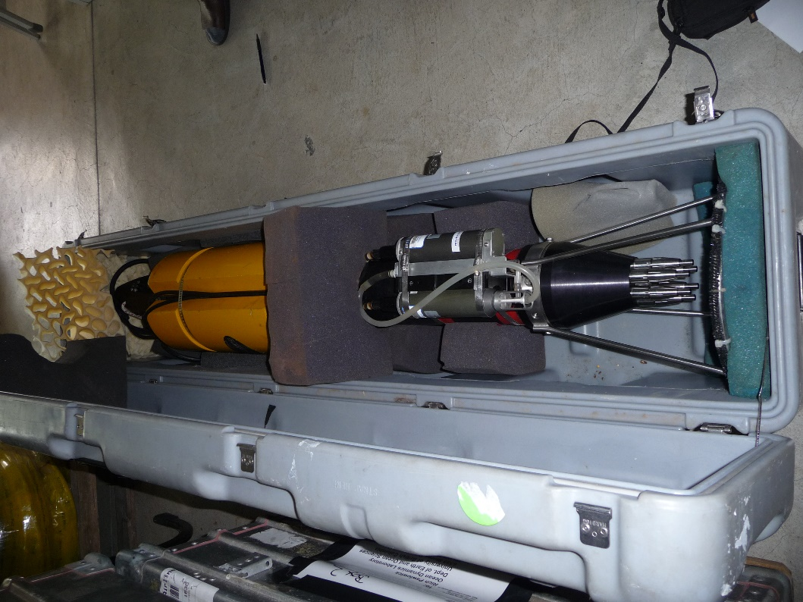

Back in the lab - Treatment and administrative tasks
- Clean the VMP and let dry before storing. When profiling brackish water (e.g. meromictic lake) or seawater rinse the instrument and sensors with tap water
- Clean CTD with distilled water. There shouldn`t be any lake water in the pipes and pump
  - Connect a pipe to the TC-duct supplied with distilled water
  - Connect a pipe to the pump-outlet going to the sink
  - Connect power cable to rinse the system with distilled water
- Fill in the remaining columns in the logbook and fill the Meta data file
  - Q:\Abteilungsprojekte\Surf\surf-KB\Aphys Messgeräte\Metadata
- Check the data. Is the CTD data reasonable?
- (If applicable) Shear microstructure data
- ODAS function quick_look. Check if shear spectra are well resolved.
- Temperature microstructure
Rockland does not provide guidelines for turbulence analysis using temperature microstructure. Some useful literature references:
  - Rudicck et al. 2000. doi: 10.1175/1520-0426(2000)017<1541:MLSFTB>2.0.CO;2
  - Sheifele et al. 2018. doi: 0.1029/2017JC013731

Changes to previous versions

41-xxx-001

